Please complete the following application if you plan to participate in Dual Enrollment/ Early College. Return to Mrs. McGillivray room 1632- YOU CAN LEAVE IN MAIN OFFICE OR EMAIL THEM TO JMCGILLIVRAY@TCSS.NET. All students who plan to participate in Dual Enrollment/Early College must have a PARTICIPATION form on file in order to participate in Dual Enrollment/Early College. If you wish to apply for a TCHS DE scholarship, please see Mrs. McGillivray.  **Scholarship Funds awarded to students who have not previously participated in the TCHS Dual Enrollment Scholarship Program**. Scholarship Funds will pay for one three-hour Dual Enrollment/Early College course and can only be awarded one time during your enrollment at Tuscaloosa County High. Funds are not guaranteed. Students who participate in Shelton Dual Enrollment are not eligible for the TCHS Scholarship at this time.

Date:____________________________________________________________________________

Student Name:______________________________________________________________________

**Which Course do you wish to take**?______________________________________

**Have you taken Dual Enrollment or Early College classes in the past**? Yes or No

Which DE program do you plan to participate in?

UA Early College

Shelton State ( A number = _______________________) NO I am a new student and need an A Number

Other:____________________________________________

**Do you want to schedule an appointment with Mrs. Mac to help with program registration**? Yes or No

Student Signature:_______________________________________ Date:________________

Parent Signature:________________________________________ Date:________________

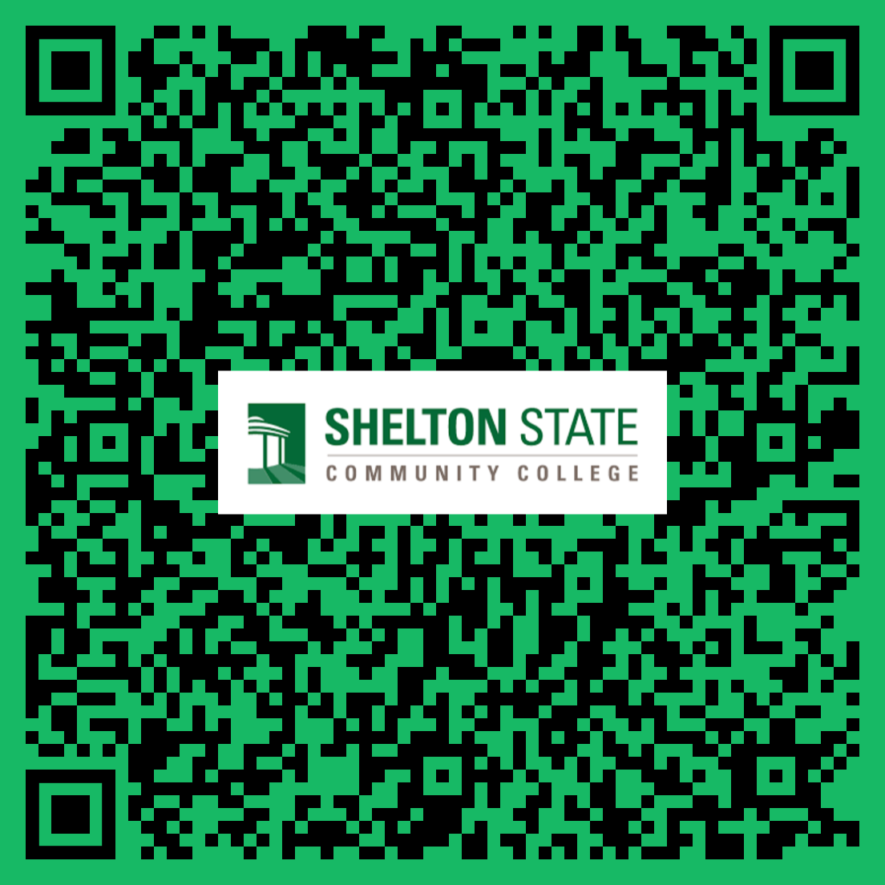

SCAN ME

Shelton State Dual Enrollment Instructions

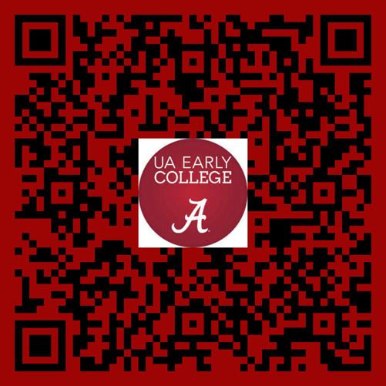

SCAN ME

UA Early College Instructions