**Reconstruction Webquest**

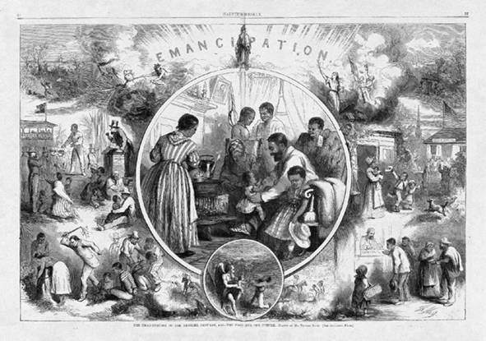The Thirteenth Amendment emancipated all U.S. slaves. As a result, after the Civil War, Southern blacks had to face the difficulty of a free people surrounded by many hostile whites. One freedman, Houston Hartsfield Holloway, wrote,

"For we colored people did not know how to be free and the white people did not know how to have a free colored person about them."

The nation was unprepared to deal with the question of full citizenship for its newly freed black population. The Reconstruction implemented by Congress, which lasted from **1866 to 1877**, was aimed at reorganizing the Southern states after the Civil War, providing the means for readmitting them into the Union, and defining the means by which whites and blacks could live together in a non-slave society. The South, however, saw Reconstruction as a humiliating, even vengeful imposition and did not welcome it.

During the **Era of Reconstruction**, Americans were attempting to rebuild following a catastrophic War. Restoring the eleven states that had seceded from the Union would be fraught with controversy, and neither the President nor congressional leaders agreed immediately on the best policy.

**Task:** In this web quest you will be exploring a period of our history known as Reconstruction.  You will be discovering the different policies and plans of this era and the struggles faced by African Americans.  In addition, you will take a look at the impacts that Reconstruction had on our constitution.

**Step 1:**

In order to become familiar with this time period in our history you will be required to complete the comparing and contrasting part of the 3 major plans for Reconstruction.

**Step 2:** Start the Web Quest

**Section 1.** **Policies of Reconstruction**

     A. Who opposed Lincoln's plan and why?  
     B. What did Lincoln do to get around the opposition?

<http://www.infoplease.com/ce6/history/A0860645.html>

     D. What did Johnson hope to accomplish by enacting a harsher plan?

<http://www.infoplease.com/ce6/history/A0860646.html>

     E. Who were Radical Republicans?

<http://www.ohiohistorycentral.org/entry.php?rec=623&nm=Radical-Republicans>

     F. How did the Radical Republicans respond to Johnson's policies?  
     G. Describe why Johnson was impeached and the outcome of the   
         impeachment proceedings.

<http://www.ohiohistorycentral.org/entry.php?rec=509>

**Section 2.**  **Struggles of the Freedmen**

A. Describe the purpose of the Freedmen’s Bureau.

B. What benefits did it offer?

http://www.history.com/topics/black-history/freedmens-bureau

C. What happened to land in the South following the Civil War?

D. Explain how the system of sharecropping worked.

E. Explain why sharecropping created a cycle of debt for farmers.

http://www.pbs.org/wgbh/amex/reconstruction/sharecrop/sf_economy.html

F. What were three ways Southerners tried to disrupt African Americans from

voting.

G. Explain how the poll tax and literacy tests were not a violation of the 15th

amendment.

H. What law was finally passed in 1965 which abolished Jim Crow era voting laws? What did it say?

<http://www.pbs.org/wnet/jimcrow/tools_voting.html>

I. Who enacted the Black Codes and what did they entail?

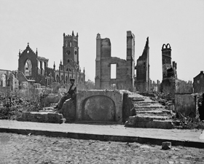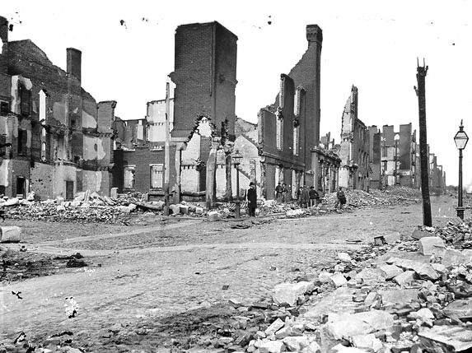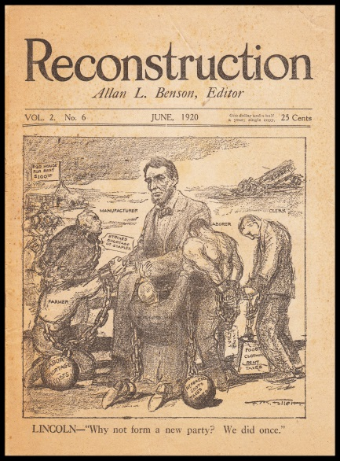http://www.history.com/topics/black-history/black-codes

    J. What was the first Ku Klux Klan and why was it formed?  
    K. Describe ways in which members frightened and abused African Americans?

<http://www.history.com/this-day-in-history/kkk-founded>

**Section 3: The 13th, 14th, and 15th Amendments**

    A. What did the 13th Amendment do?

<http://www.ourdocuments.gov/doc.php?flash=true&doc=40>

    B. What group showed the strongest support for the 13th Amendment?

<http://www.u-s-history.com/pages/h127.html>

C. What did the 14th Amendment do?  How did it attempt to protect African  
        Americans?

<http://www.loc.gov/rr/program/bib/ourdocs/14thamendment.html>

<http://www.pbs.org/wnet/jimcrow/stories_events_14th.html>

    E. Describe what the 15th Amendment did for African Americans.  
    F. How did Southerners get around the 15th Amendment?

<http://www.loc.gov/rr/program/bib/ourdocs/15thamendment.html>

