**Westwood Elementary**

**Pre-K Wish List**

**2022-2023**

**\*\*$40/month Classroom Donation\*\*** (due the 1st day of each month)

Items children need each day:

**□** Backpack (to be brought to school each day)

**□** Change of clothes, socks, & underwear in case of an accident

(put in Ziploc bag & label with child’s name)

**□** Nap Mat (with pillow & blanket attached)

Wish List Items:

**□** 1 pair of kid-sized headphones (labeled with your child’s name)

**□** 1 pack of small cups (12 oz.)

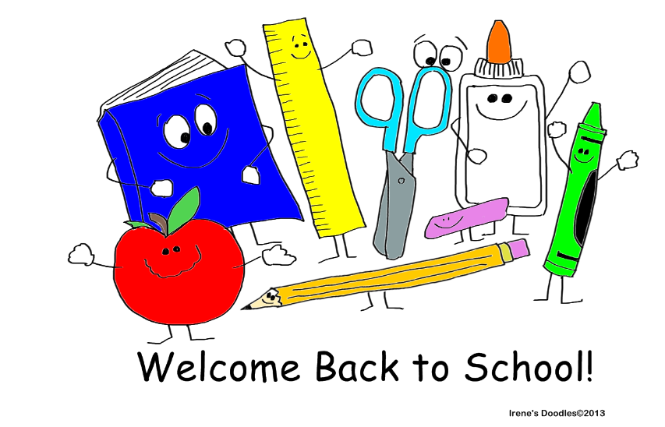**□** 1 pack of baby wipes

**□** 2 rolls of paper towels

**□** 1 bottle of dish soap

**□** 1 bottle of liquid hand soap

**□** 2 container of disinfectant wipes

**□** 1 pack of dry erase markers