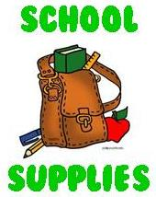Westwood Elementary   
Pre-K supply list:



[This Photo](http://olfschool.wikispaces.com/Pre-Kindergarten+2) by Unknown Author is licensed under [CC BY-SA](https://creativecommons.org/licenses/by-sa/3.0/)

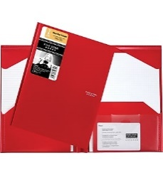  
**$40.00/month  Classroom Fee** due the first of each month  
  
Backpack brought to school each day  
  
Mead Five Star Stay-Put Pocket Folder with prongs   
Please check daily for notes    
  
1 pair of kid sized headphones  
1 pack white card stock  
1 container Clorox Wet Wipes  
1 roll paper towels  
1 box Kleenex  
1 package of wet wipes

1 bottle of liquid hand soap  
1 container of Playdough  
1 package 6” white paper plates  
1 package quart sized ziplock bags  
4 boxes 8 count crayola crayons 1 box Crayola washable markers 1 glue stick   
1 box sharpened pencils

Cloth Napmat with pillow and cover attached

Diapers or pull-ups (if needed) labeled with name  
**Change of clothes to leave in backpack in case of accidents. Please put in ZipLoc bag