**Lab: Virtual Transport in Cells**

**Name:**

**Date:**

Go to the following website: <http://www.linkpublishing.com/video-transport.htm>

Click on “Brownian movement”

1. **Define BROWNIAN MOVEMENT in your own words**

Click to watch the video of Brownian motion in milk. (High Power observation is recorded using the High Power Objective and Oil Immersion is recorded using a compound light microscope objective that magnifies even more than high power) – open the file using Windows Media Player

1. **Describe the molecules observed under oil immersion**

Scroll down to “Osmosis”

1. **Define OSMOSIS in your own words**
2. **In the illustration shown, why does water move to side “A”?**

Scroll down to “Elodea – Osmosis”

1. **What is Elodea?**
2. **What is the HYPOTONIC solution for Elodea?**
3. **Why do plant cells not burst even in a HYPOTONIC solution?**

Click to watch the video of fresh (normal) Elodea – open the file using Windows Media Player (you can pause and rewind any time you need)

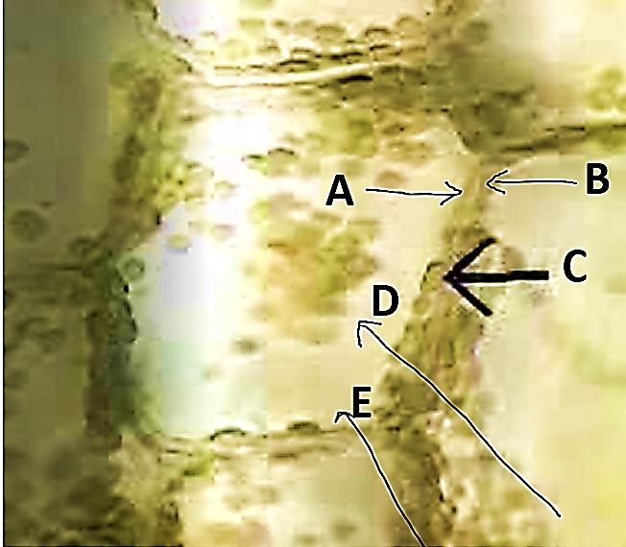

1. **Label this cell in a normal (called ISOTONIC) solution with the following: cell wall, central vacuole, cytoplasm, chloroplast, plasma membrane**

**A.**

**B.**

**C.**

**D.**

**E.**

Notice that the chloroplast appear to be “moving” around the cells because the cytoplasm is moving.

Scroll down to “Elodea – Hypertonic Solution”

1. **Define HYPERTONIC solution in your own words**
2. **What happens to cells in a HYPERTONIC solution?**

Click to watch the video of normal Elodea subjected to a hypertonic solution – open the file using Windows Media Player (you can pause and rewind any time you need)

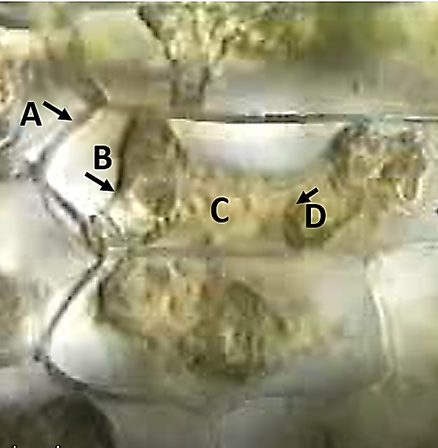

1. **Label a cell in this HYPERTONIC solution with the following: cell wall, central vacuole, chloroplast, plasma membrane**

**A.**

**B.**

**C.**

**D.**

Scroll down to “Elodea – Hypertonic Cells in a Hypotonic Solution”

1. **Define HYPOTONIC solution**
2. **What should happen to shrunken/crenated Elodea cell (that was in a hypertonic solution) if you place it in a hypotonic solution?**

Click to watch the video of plasmolyzed Elodea subjected to a hypotonic solution – open the file using Windows Media Player (you can pause and rewind any time you need)

1. **Describe what you see happening to the cells**

Scroll down to “Blood – Isotonic Solution”

1. **Why are red blood cells ideal cells for the study of the effects of osmosis?**
2. **Define ISOTONIC solution in your own words**
3. **What happens to cells in an isotonic solution?**

Click to watch the video of blood in an isotonic solution – open the file using Windows Media Player (you can pause and rewind any time you need)

1. 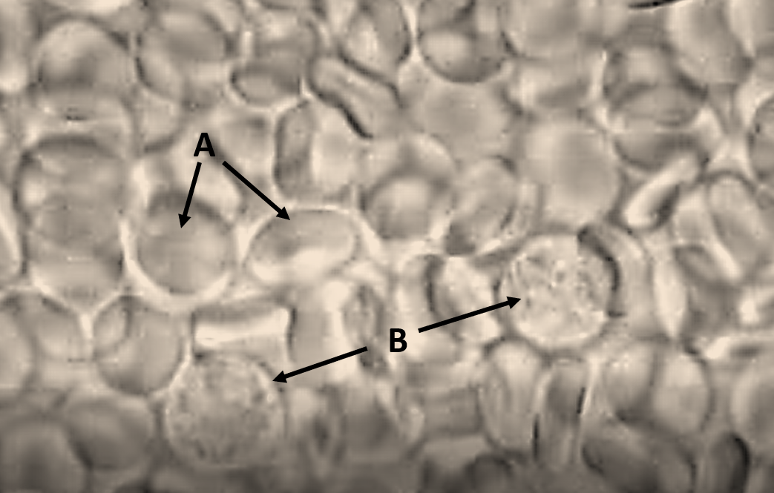**Label the type of blood cells (Red Blood Cells and White Blood Cells) in the ISOTONIC solution.**

**A.**

**B.**

Scroll down to “Blood – Hypertonic Solution”

1. **What causes a red blood cell to be CRENATED?**

Click to watch the video of normal RBCs subjected to a hypertonic solution – open the file using Windows Media Player (you can pause and rewind any time you need)

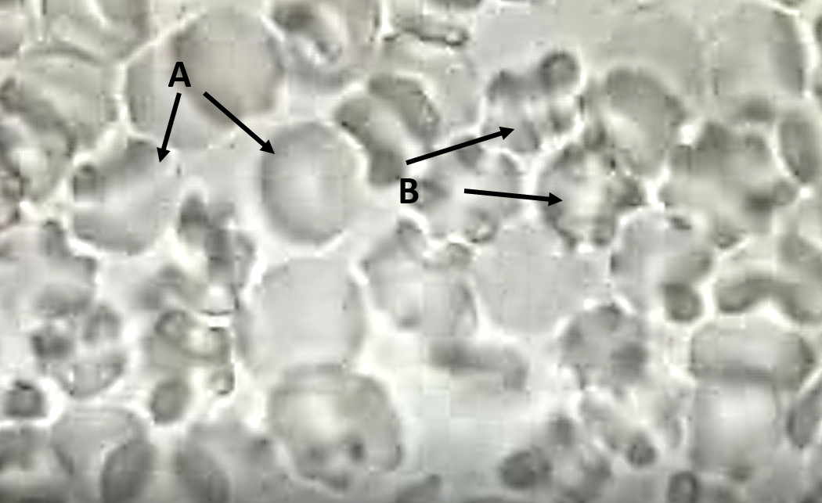

1. **Identify which red blood cells are CRENATED and which are not yet crenated in the HYPERTONIC solution.**

**A.**

**B.**

Scroll down to “Blood – Hypotonic Solution”

1. **What does “lysis” mean in your own words?**

Click to watch the video of crenated RBCs subjected to a hypotonic solution” – open the file using Windows Media Player (you can pause and rewind any time you need)

1. 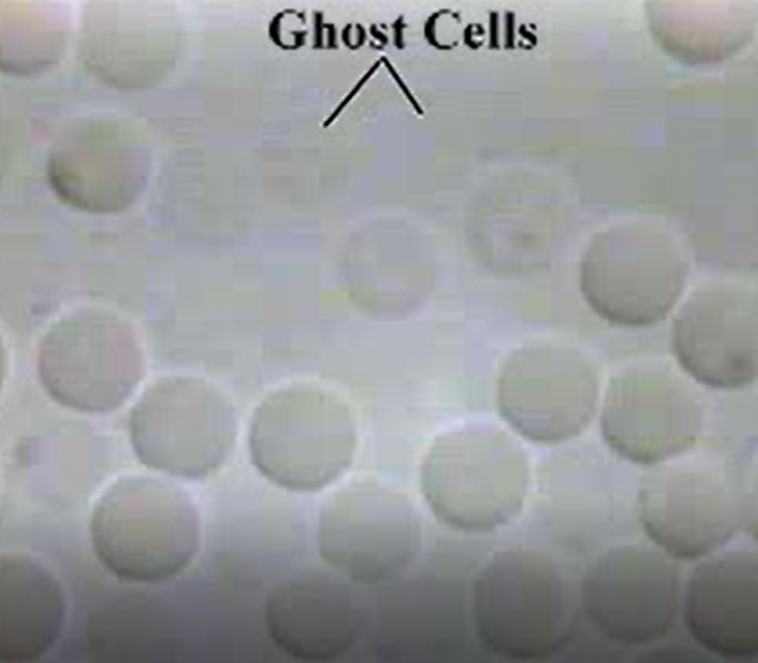**Describe what has happened to the red blood cells that were crenated but are now placed into a HYPOTONIC solution (describe what happened to the red blood cells before they become “ghost cells”).**

Scroll down to “Osmosis – Red Onion”

Click to watch the video of osmosis in red onion – open the file using Windows Media Player (you can pause and rewind any time you need)

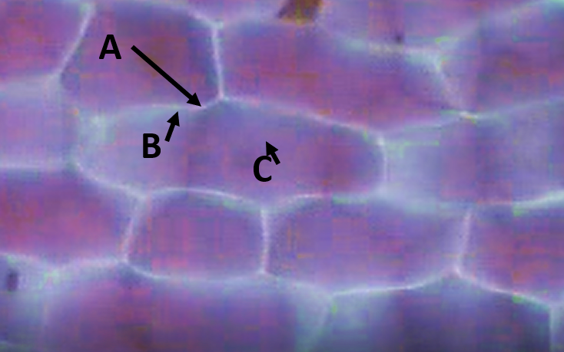

1. **Label these onion cells in an ISOTONIC SOLUTION with the following: cell wall, central vacuole, plasma membrane**

**A.**

**B.**

**C.**

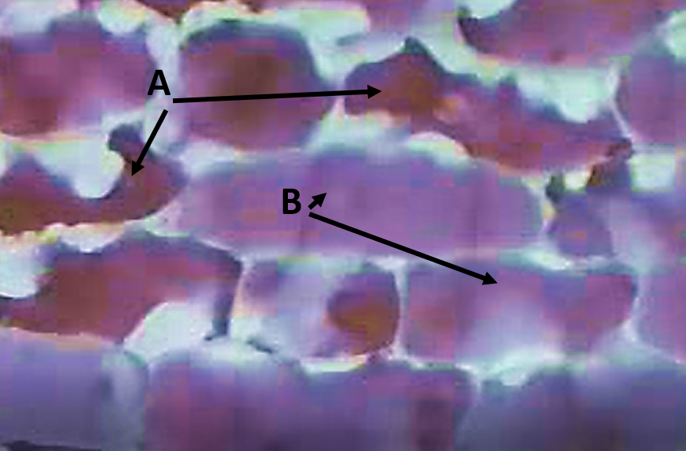

1. **Identify which of the NORMAL red onion CELLS SUBJECTED TO HYPERTONIC SOLUTION are PLASMOLYZED (shrinking) and which are not yet PLASMOLYZED.**

**A.**

**B.**

1. **Looking at the red onion “CRENATED CELLS SUBJECTED TO A HYPOTONIC SOLUTION, note that not all of the cells in the video segment are exposed to the HYPOTONIC solution. Using this image, identify which side of the view was receiving the HYPOTONIC solution and explain why.**

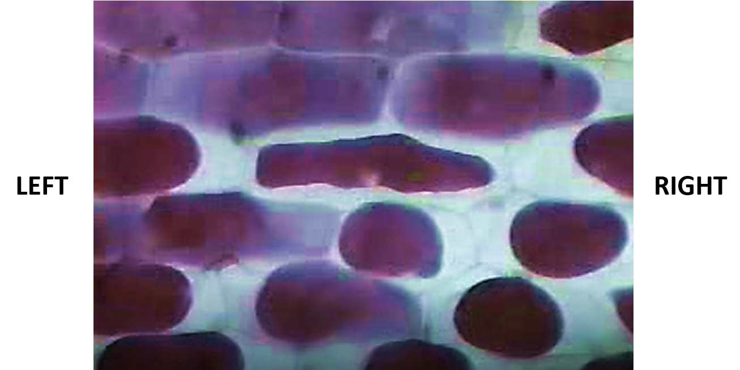

1. **Which side of the view was exposed to the HYPOTONIC solution?**
2. **How do you know/what observation makes this obvious and what is happening?**

Scroll down to “Paramecium – Contractile Vacuoles and Osmosis”

1. **What is the HYPOTONIC solution for *Paramecium*?**
2. **What is the function of the CONTRACTILE VACUOLES in your own words?**

Click to watch the video of contractile vacuoles of *Paramecium* – open the file using Windows Media Player (you can pause and rewind any time you need)

1. **Describe what the contractile vacuoles look like when they are functioning.**

Scroll down to “Bulk (Vesicular) Transport”

1. **What does bulk transport include?**
2. **What is PHAGOCYTOSIS in your own words?**
3. **What is PINOCYTOSIS in your own words?**

Scroll down to “*Paramecium* – Endocytosis”

1. **Why does the eosin (red) color change to blue in some of the food vacuoles?**

Click to watch the video of ENDOCYTOSIS, formation of food vacuoles of *Paramecium* – open the file using Windows Media Player (you can pause and rewind any time you need)

In the video, even though it doesn’t look like the cell membrane is invaginating (engulfing) the food as the food vacuole is made this is because cells are three-dimensional and the compound light microscope can only focus on one dimension/plane at a time.

Scroll down to “*Paramecium* – Exocytosis”

1. **What kind of things would a cell get rid of using EXOCYTOSIS?**

Click to watch the video of EXOCYTOSIS, secretion of food vacuoles from *Paramecium*”

1. **Describe what you observe happening when the cell is doing EXOCYTOSIS.**

**Vocabulary Review**

Review the vocabulary explored in this activity by completing the following matching (descriptions/examples **may be used more than once**)

|  |  |  |  |
| --- | --- | --- | --- |
|  | **Vocabulary Term** |  | **Description or Example** |
|  | BROWNIAN MOVEMENT |  | Cell “drinking” |
|  | CONTRACTILE VACUOLE |  | Cell “eating” |
|  | ENDOCYTOSIS |  | Formation of food vacuoles |
|  | EXOCYTOSIS |  | Helps to maintain water balance in single-celled eukaryote cells by collecting and expelling water from the cell |
|  | HYPERTONIC |  | Movement of water across a semi-permeable membrane from where there is more water to where there is less water |
|  | HYPOTONIC |  | Random movement of particles caused by molecule collisions |
|  | ISOTONIC |  | Removing wastes from a cell |
|  | LYSIS |  | Solution that contains an equal amount of solutes and solvent |
|  | OSMOSIS |  | Solution that contains less solute |
|  | PHAGOCYTOSIS |  | Solution that contains more solute |
|  | PINOCYTOSIS |  | Tears in the cell membrane |

**Cell Transport Review**

Review the concept of tonicity for cells by identifying what type of solution the cell is exposed to and what will happen to the cell in each of these examples.

|  |  |  |  |
| --- | --- | --- | --- |
| **Description** | **Type of Solution outside the cell (Isotonic, Hypertonic, Hypotonic)** | **What does water do? (move inside, move outside, move equally inside and outside)** | **What happens to the cell? (shrink, swell, stay the same)** |
| A *Paramecium* that is placed into a salt-water fish tank. |  |  |  |
| A red blood cell that is placed in normal saline. |  |  |  |
| A red onion cell that has plasmolyzed and is now flooded with fresh water. |  |  |  |