*WELCOME* to

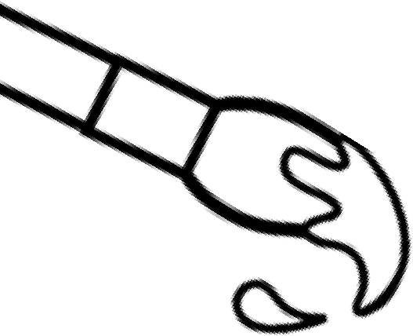**ART**  Ms. Humphreys - [abhumphreys@tcss.net](mailto:abhumphreys@tcss.net) - Room B132

-------------------------------------------------------------------------------------------------------------------------

**Introduction to Visual Arts I** (one credit OR one-half credit) - This novice level course is the first of a sequential high school course. Creating, presenting, responding and connecting drive critical thinking, meaning, reflection, production and assessment to understand how visual arts communicate ideas and allows for self-expression. Through exploration and experimentation, this course provides students with a general foundation in studio processes, art criticism, aesthetics, and art history. Students respond to personal experiences and express ideas using a variety of traditional and contemporary media while effectively applying the elements of art and principles of design to create original works of art. Safe practices and proper use of tools and materials are emphasized. Prerequisite: None. Fee: $25.

**Visual Arts II** (one credit OR one-half credit) - This intermediate level course is the second of a sequential high school course. Creating, presenting, responding and connecting drive critical thinking, meaning, reflection, production and assessment to understand how visual arts communicate ideas and allows for self- expression. Through exploration and experimentation, this course provides students with a more in-depth study of foundations in studio processes, art criticism, aesthetics, and art history. Students respond to personal experiences and express ideas using a variety of traditional and contemporary media while effectively applying the elements of art and principles of design to create original works of art. Safe practices and proper use of tools and materials are emphasized. Prerequisites: Introduction to Visual Arts I and Teacher Recommendation. Fee: $25.

**Visual Arts III** (one credit OR one-half credit) - This accomplished level course is the third of a sequential high school course. Creating, presenting, responding and connecting drive critical thinking, meaning, reflection, production and assessment to understand how visual arts communicate ideas and allows for self- expression. Through exploration and experimentation, this course provides students with a comprehensive study in studio processes, art criticism, aesthetics, and art history. Students respond to personal experiences and express ideas using a variety of traditional and contemporary media while effectively applying the elements of art and principles of design to create original works of art. Safe practices and proper use of tools and materials are emphasized. Prerequisites: Visual Arts II and Teacher Recommendation. Fee: $25.

**Visual Arts IV** (one credit OR one-half credit) - This advanced level course is the fourth of a sequential high school course. Creating, presenting, responding and connecting drive critical thinking, meaning, reflection, production and assessment to understand how visual arts communicate ideas and allows for self- expression. Through exploration and experimentation, this course provides students with an advanced study in studio processes, art criticism, aesthetics, and art history. Students respond to personal experiences and express ideas using a variety of traditional and contemporary media while effectively applying the elementsof art and principles of design to create original works of art. Safe practices and proper use of tools and materials are emphasized. Prerequisites: Visual Arts III and Teacher Recommendation. Fee: $25.

-------------------------------------------------------------------------------------------------------------------------



-------------------------------------------------------------------------------------------------------------------------

**Supplies**:

\**The course fee is used to purchase supplies for in class use.*\*

The following list will be basic supplies for remote learners or those who choose to bring their own materials.

* 9 x 12 Sketchbook
* #2 Pencils
* Pencil Sharpener
* Block Eraser
* Black Sharpie (Fine & Regular)
* Colored Pencils
* Markers
* Watercolor Set
* Assorted Paint Brushes
* Scissors
* Glue Stick
* Ruler

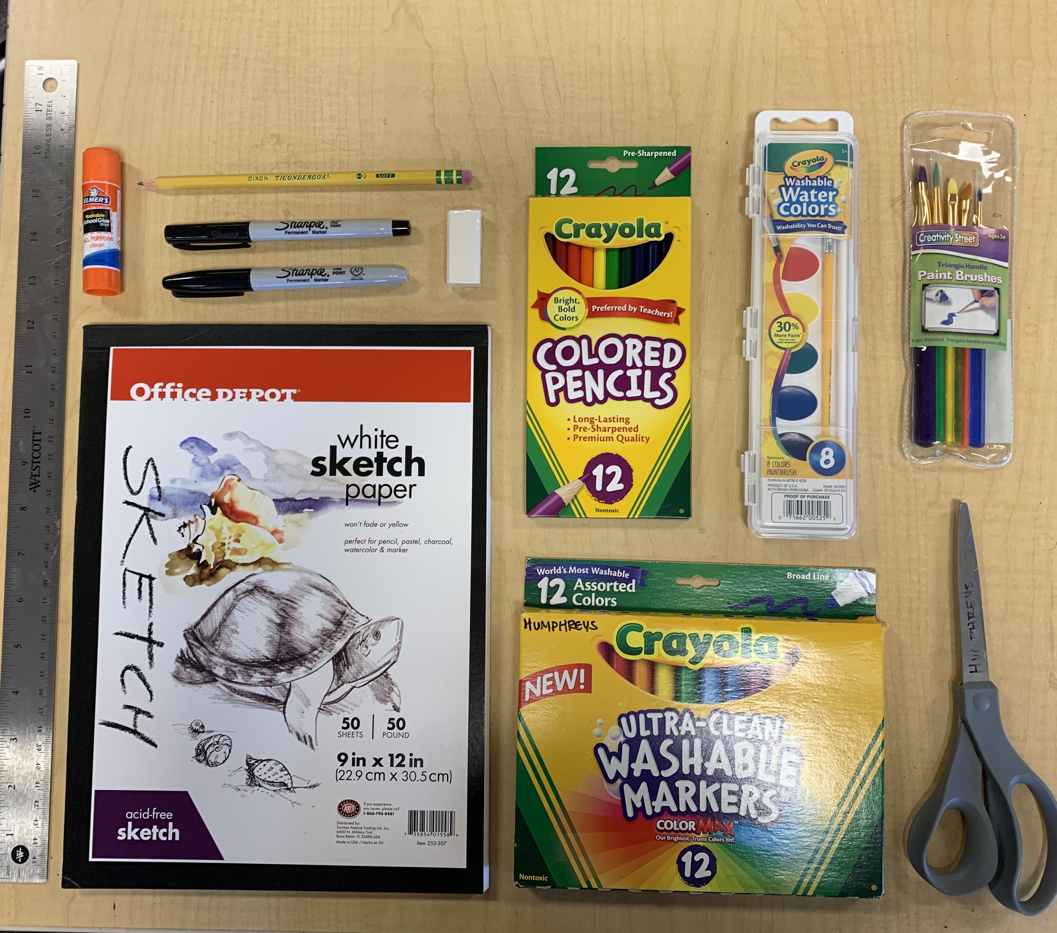

-------------------------------------------------------------------------------------------------------------------------

**Expectations**: Be Prompt, Prepared, Productive, Positive and Polite

-------------------------------------------------------------------------------------------------------------------------

**Discipline**:

\**Applies to infractions that do not require an immediate office referral.*\*

* 1st Offense: Warning
* 2nd Offense: Parent Contact
* 3rd Offense: Office Referral

-------------------------------------------------------------------------------------------------------------------------